**A**

**Project Report**

**On**

**"Result Analysis Using Python"**

**Prepared by**

Mink Virparia (16IT144)

**Under the guidance of**

Mr. Ravi patel

Assistant Professor

A Report Submitted to

Charotar University of Science and Technology

for Partial Fulfillment of the Requirements for the

5th Semester Software Group Project-II

**Submitted at**



**DEPARTMENT OF INFORMATION TECHNOLOGY**

**Chandubhai S. Patel Institute of Technology**

**At: Changa, Dist: Anand – 388421**



**CERTIFICATE**

This is to certify that the report entitled “**Result Analysis Using Python**” is a bonafied work carried out by **Mink Virparia(16IT144)** under the guidance and supervision of **Assistant Prof.Ravi Patel** for the subject **Software Group Project-III** (IT of 5th Semester of Bachelor of Technology in **Information Technology** at Faculty of Technology & Engineering – CHARUSAT, Gujarat.

To the best of my knowledge and belief, this work embodies the work of candidate himself, has duly been completed, and fulfills the requirement of the ordinance relating to the B.Tech. Degree of the University and is up to the standard in respect of content, presentation and language for being referred to the examiner.

|  |  |
| --- | --- |
| Mr. Ravi Patel  Assistant Professor  Dept. of Information Technology  CSPIT, Changa, Gujarat. |  |
| Prof. Parth Shah  Head & Associate Professor  Department of Information Technology  CSPIT, Changa, Gujarat. | |

**Chandubhai S Patel Institute of Technology**

At: Changa, Ta. Petlad, Dist. Anand, PIN: 388 421. Gujarat

**Acknowledgment**

I am extremely thankful to my internal guide **Mr. Ravi Patel** whose constant support and helping attitude towards the students has always provided us the strength to complete the task efficiently and rapidly.

I sincerely thank Sir for his expert guidance and encouraging me throughout this project work.

**Abstract**

As we all know that nowadays people are habitual to compare result in each and every situation (like scorecard, climate changes, student results).So, It is necessary to have a system that can generate graph using students result in graphical form.

In this project, Result analysis using python, people can see different graph for the appropriate subject or year.

**Index**

|  |  |  |
| --- | --- | --- |
| CHAPTER  NO. | CHAPTERNAME | PAGE  NO. |
| 1 | Project Definition | 6 |
| 2 | Description | 7 |
| 3 | Requirements | 8 |
| 4 | Major Functionality | 9 |
| 5 | Screenshots | 10 |
| 6 | Limitations | 14 |
| 7 | Outcome | 15 |
| 8 | Future Enhancement | 16 |
| 9 | References | 17 |

**Project Definition**

My project is based on the result analysis of the data and then data is generate in the form of graph. With the easy, more featured and trending language, Python, I have selected this language to build this project.

**Description**

First of all, I have Created an dummy data of the different subjects which are coming in different semesters of Approximately 150 students in the Excel Sheet. Then using python graphical library (i.e Matplotlib), I have imported that Sheet and then using it’s plotting charactersitics, graphical Interepretation method and different Interactive styles to represent any data in graphical form, I have made a Program which can give different graphs and an clear cut idea about analysis of the previous year’s result with the present result.So, It is useful for the professor, Student’s to compare the results in graphical form.

**Requirements**

* **Software Requirements:**

1. Windows OS

2. Python IDLE

3. Python Libraries

i.Matplotlib

ii.Numpy

**Major Functionality**

My project is based on Result Analysis Using Python, Which functionly read the innumerous data from the imported file and generate different types of graphs (i.e line graph, bar graph, pie chart, etc.) using python library (i.e matplotlib). Basically it fetches the value from the imported file and using it’s plotting charactersitics, graphical Interepretation method and different Interactive styles to represent any data, it generates the graphs.

You can analayze any result in the graphical form using this project. So, it can be helpful to professor as well as students also to check the comparison of previous years data to current years data.And it provides you the proper visualization of the result in the graphical form.

**Screenshots**

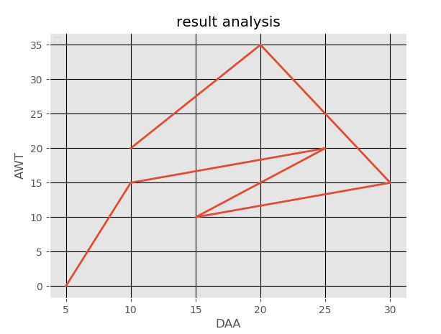

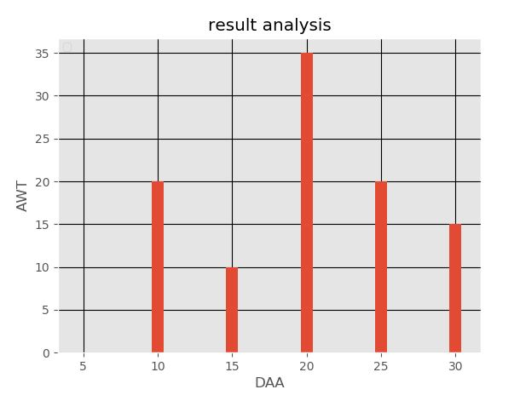

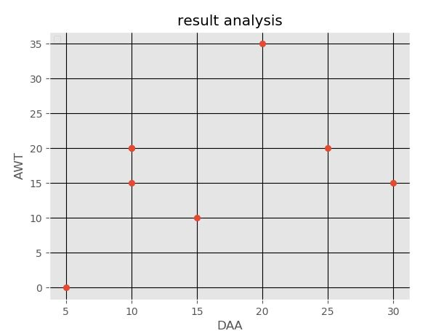

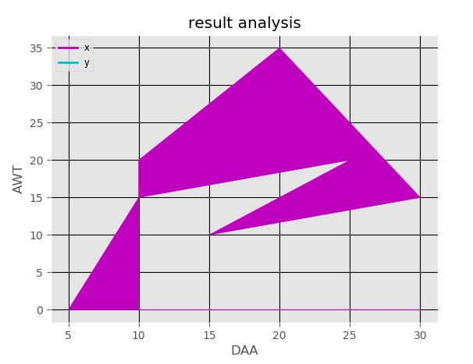

**Limitations**

Due to less time and more things to learn in my project, I have not made any webpage connection with my project.So anyone cannot select any options because there is no webpage based application.It only shows you the result analysis from the excel sheet which is imported and you will get different types of graph from analysis.

**Outcome**

Nowadays, people are facing problem in analyzing the data and using it, generating the graph.Therefore I have build this project which can deal with the data and provide you approriate graph from the result in the simple and easy way.

So, User just have to select any 2 column for which they have to generate an graph.

**Future Enhancement**

In future, I would like to add some more features like it will directly merge

With the E-governace and any student or any professor can compare the result of any department or any year. And I would like to more precise and more variety of graphs in the system.

And I will surely fix bugs and error which we have come across during development of this project.

**References**

* [www.udemy.com/complete-python-bootcamp](http://www.udemy.com/complete-python-bootcamp)
* [www.matplotlib.org](http://www.matplotlib.org)
* <http://pythonprogramming.net/matplotlib-python-3-basics-tutorial/>
* [www.tutorialspoint.com/numpy/numpy_matplotlib.htm](http://www.tutorialspoint.com/numpy/numpy_matplotlib.htm)
* <http://www.youtube.com/Matplotlib-Tutorial-series-graphing-in-python/>